Bansilal Ramnath Agarwal Charitable Trust’s

Vishwakarma Institute of Technology, Pune-37
(An autonomous Institute of Savitribai Phule Pune University)


Department of Multidisciplinary Engineering

Division | AIML-A
Batch | 01
GR No. | 05
Roll No. | 08
Name | Abhishek Anil Patil

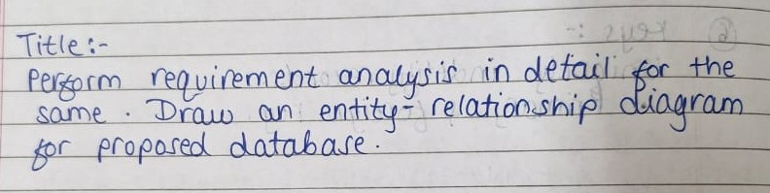
Description: Our project, Workout Planner, helps users track workouts and receive diet recommendations. The ER diagram shows the main entities, their attributes, and relationships. User Profile stores personal details and links to training records and diet recommendations. Equipment is linked to exercises, which connect to training records. Recipes with nutritional details link to diet recommendations for users. Standard ER symbols are used to represent the structure and connections clearly.

ER Diagram:

